**CHAPTER 1**

**INTRODUCTION**

India’s Public Distribution System (PDS) with a network of 4.78 Lakh Fair Price Shops (FPS) is perhaps the largest retail system in the world. Public distribution system i.e. rationing distribution is one of the widely controversial issues that involves corruption and illegal smuggling of goods. One reason of this to happen is because every job in the ration shop involves manual work and there is no Special technology involved in automating the job. Involvement of manual work calls a lot of irregularities.

These irregularities or illegal activities are for example - wrong entries in stock register of shop containing wrong stock information of the products that is supplied to the public, sometimes there are chance of distribution of low quality/graded products than the actual products provided by the Government. Major problems due to this system are the inefficiency in the targeting of beneficiaries and the resulting leakage of subsidies. The TPDS system today supports over 40 Crore Indians below the poverty line with monthly supply of subsidized food grains.

The Government of India is having a UID number system called AADHAR number, which contains all general information like age, count of family, finger print of the family, address, contact numbers, bank account information etc. for every resident in the country. Using the AADHAR number and the contact details, the Government can send a message (SMS) to the individuals, containing information regarding quality and quantity of products allotted to him/her in a respective ration shop. People who are accessing the ration shop for subsidies in the cost of products would allot a smart card that is electronic ration card.

In the recent scenario, all the public and private sectors go for automation process. Civil Supplies Corporation is the major public sector which manages and distributes the essential commodities to all the citizens. The automatic rationing system, installed at the ration shop which contains three interfaces namely touch screen, billing printer and GSM. All these interfaces are interfaced to the advanced microcontroller. Embedded PIC Microcontroller is interfaced to the PLC and further to the central database of the government.

The person would have to swipe the card on the system placed at ration shop counter. Once authenticated, automatic rationing system would get updated information regarding the existing subsidies for the current user in the screen. The inputs are given by the consumer and select the products by the consumer itself in the touch screen.

From the LCD display the inputs are given to the microcontroller unit, and the products are obtained from the automated ration shop. Further to prevent irregularities in distribution of ration, government can supply various products to rationing shops in the form of sack stored in the container. Central database would be updated immediately after every transaction made by the users.

**CHAPTER 2**

**LITERATURE SURVEY**

**2.1 AUTOMATION IN RATIONING SYSTEM USING ARM7**

**2.1.1 INTRODUCTION**

The Concept is to automate the Public Distribution System (PDS), A Govt. Of India initiative Process in which a fixed amount of ration is provided monthly to the people by the PDS stores. Because of the increased corruption in the market sector can be prevented if system becomes automated, increased adulteration can be prevented as well, the hoarding done by the officials and labours of Govt. Super Bazaars(PDS Stores) which in turn leads to price hike can be prevented using this system. The apparatus used for designing is cost effective and can prove helpful to Govt. of India’s PDS System and to various other disciplines. In terms of feasibility it is a vast concept and an interesting task to perform and totally feasible in all aspects technical as well as other. [1]

**2.1.2EXISTING RATIONING SYSTEMS**

**Web enabled ration distribution system**

To overcome one of the corruption problem involve in ration distribution system through Hooper valve to control openings of ration outlet etc. No involvement of any person directly with distribution system, also whether kerosene disposition is also sensed at web site using proximity sensor through web giving a clear idea about delivery of it.

**Bar-coded ration cards**

Issue of new BARCODED RATION CARDS having 2D barcode on it. BARCODE contains some crucial information of Ration card. i) The BIOMETRIC data of at least 1 member/card is captured as per ISO standard (ISO 19794-4 and 19794-2 (minutiae)).

ii) Establishing the identity of a person through convergence of Ration Card data with EPIC, BPL, GAS, Electricity, Job Cards. Food coupons to the beneficiaries to avail the commodity covered in Public Distribution System. The food coupons can be printed from e-gram/cyber café on biometric verification of beneficiaries.

* + 1. **LIMITATION OF CONVENTIONAL SYSTEMS**

i) Illegal Usage

ii) Cannot able to get the accurate quantity of supplies

iii) Over crowd

iv) Unable to get the material at any time

v) Processing speed is slow

vi) Selection of households – Targeting

vii) Bogus cards

viii) Hijacking of ration cards

ix) Poor quality of supplies

x) More than the prescribed rates are charged

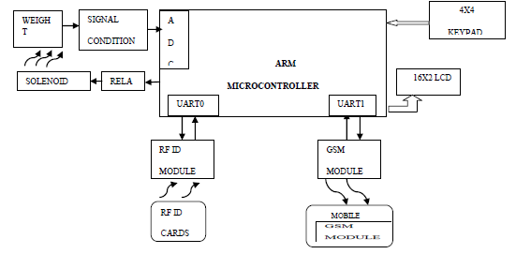

Fig 2.1 Block diagram of ARM 7 automation system

* + 1. **FEATURES AND BENEFITS**

Following are some of the features of the System: -

1. Increased corruption in the Govt. As well as market sector can be prevented if system becomes automated

2. Increased adulteration in consumables can be prevented

3. The problem of hoarding at Govt. Super Bazaars (PDS Stores) that gives rise to price hike can be prevented

4. Cost-effective approach

5. Time saving approach

* 1. **AUTOMATION OF RATION SHOP USING PLC**

**2.2.1 INTRODUCTION**

In recent scenario, all the public and private sectors go for automation process. Civil Supplies Corporation is the major public sector which manages and distributes the essential commodities to all the citizens. In that system various products like Rice, sugar and kerosene are distributed using conventional ration shop system. Some of the limitations of conventional ration shop system are Due to the manual measurements in the conventional system, the user can not able to get the accurate quantity of material. And also there is a chance for the illegal usage of our products in the conventional system. i.e. the materials are robbed by making wrong entries in the register without the knowledge of the ration card holder. Due to that large amount of money given by government gets wasted.

The Ration shops cannot able to meet the requirements of the user due to the over population of our country. So the processing speed is low As a result, there is always crowd of people in the ration shop. Due to the human operations the working hours of the ration shops are restricted; so that the user cannot able to get the material at any time i.e. 24 * 7 basis. To overcome these problems the automation of the ration shops using embedded PLC is being implemented.

In this project, the parameters Level and Load has been desired to be controlled by GEFANUC PLC. Some of the commodities distributed under Public Distribution system are Rice, Kerosene and Sugar In this project the hardware for two commodities namely Sugar and Kerosene has been designed. These two commodities are stored in reservoir tanks and are measured and supplied to the user as and when required. The user has to enter the required product and quantity using a keypad and display. For the measuring purposes, a load cell for sugar and Resistance type Ball float Level Sensor for Kerosene has been used. And these parameters are controlled by the Embedded PLC GEFANUC. Motorized gate valves are used for the measurement and delivery operations. Four tanks are designed, two of them are reservoir tanks and another two of them are delivery tanks. [2]

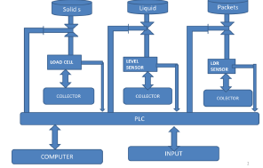

Fig 2.2 Block diagram of PLC automated ration shop

* + 1. **ADVANTAGES**
* Reliability
* PLC along with upper computer raises the system reliability
* The upper computer is not with the real time control process of PLC, except gives the order of initial process parameters and control; therefore, the upper computer is off-line, PLC can successfully go through the production
* Mixed programming with high-level and assembly languages
* Not only ensure the system reliability, but also benefit for software upgrade
* Make operation easy and intuitive
* Visualization
* Flexibility
* Bring transparent

**2.3 AUTOMATIC RATION MATERIAL DISTRIBUTION USING GSM AND RFID TECHNOLOGY**

**2.3.1 INTRODUCTION**

Most of the people have a ration card to buy the materials from the ration shops. When commodities ought to be purchased from the ration shop, initially the ration card has to be submitted and the people in-charge would sign in the ration card based on the commodities. After which the materials would be issued through a weighing system. But this system has two draw backs, the first one is the weight of the material may be inaccurate due to human mistakes and secondly, if the commodities are not brought by the end of the month, it would be sold to others without any intimation to the government as well as the customers.

In system, Automatic Ration Materials Distribution Based on GSM and RFID Technology has been proposed to avoid the drawbacks. Today number of transport related problems are being faced by everyone. RFID technology is effectively used to solve some of them. RFID acts as a ration card and other purposes such as RC book, insurance details, service details etc. GSM is used to communicate the information between the two people or more than two persons to update the information based on the requirements. [3]

* + 1. **PROPOSED SYSTEM AND ITS PURPOSE**

The Automatic Ration Materials Distribution Based on GSM and RFID Technology used to distribute or vend the liquid or solid material, which is used for Ration materials distribution in ration shops. Initially the customer would be provided an RFID or smart Card, instead of a ration card. If the customer needs to get any ration material, the user has to show the ration RFID tag card to the RFID reader Kit, the reader that is incorporated with the Micro-Controller will recognize the RFID numbers show by the user. This recognized RFID number will be given to a microcontroller, which compared the input number with the database.

Before starting the system, the unique RFID number of the ration user will be programmed in the controller, such as User name & address details, date of expire of ration card, etc., so that the controller will recognize the data coming from RFID by comparing with the database.

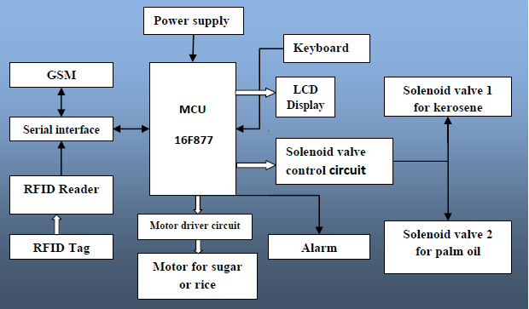

Fig 2.3 Block diagram of GSM and RFID based system

Once the user is identified, the microcontroller will check whether the user has already bought the ration item belonging to that month. If the user, select the ration item for purchasing purposes then the controller will calculate the amount of his or her buy and check with the amount available in the RFID card. If he or she has sufficient amount to buy then the micro controller will start the solenoid and motor mechanism to dispense the selected ration item. The controller will send a command to GSM Modem, to send the text SMS to the user about the ration item, he or she purchased. Before starting the process the amount of the item to be dispensed has to be calibrated separately then the only controller will dispense the correct quantity of ration item selected

* 1. **AUTOMATING RATIONING FOR PUBLIC DISTRIBUTION SYSTEM USING RFID AND GSM TO PREVENT IRREGULARITIES**

**2.4.1 INTRODUCTION**

The Government in India is having a UID number system called AADHAR number, which contains all related information such as address, contact numbers, bank account information etc. for every resident in the country. Using the AADHAR number and contact details, the Government can send a message (SMS) to the individuals, containing information regarding quality and quantity of products allotted to him/her in a respective/specific ration shop.

People who are accessing the ration shop for subsidies in the cost of products would be allotted a smart card (electronic ration card). This card is a RFID based card containing all information about the users such as his/her AADHAR number, name and count of family members, profession, age etc. The automatic rationing system, installed at the ration shop would have three subsections i.e. smart card interfacing to microcontroller, microcontroller and display, GSM module interfacing to microcontroller as well as central database provided by the Government. The person would have to swipe the card on the system placed at ration shop counter. After that for security authentication and to prevent card misuse, the system would ask for the AADHAR number. With the correct entry of password (i.e. AADHAR number) the GSM module would send message to central database for user identification. Once authenticated, automatic rationing system would get updated information regarding the existing subsidies for the current user. Further to prevent irregularities in distribution of ration, Government can provide/supply various products (like rice, wheat, kerosene, cooking oils etc.) to rationing shops in the form of sealed packets instead of the sack. The packets size can be in the following denominations (1 Kg, 2 Kg, 4 Kg, 8 Kg, 1 Lt , 2 Lt, 4 Lt, 8 Lt etc). User can only take the subsidies on products allotted to him/her by Government according to the available database records.

Central database would be updated immediately after every transaction made by the users.[4]

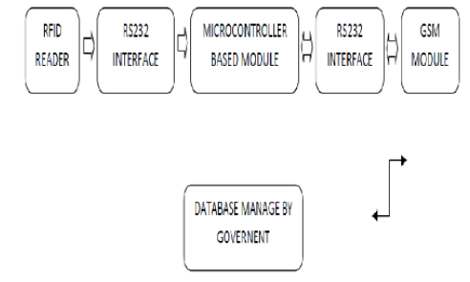

Fig 2.4 Block diagram of irregularities prevented automated system

* + 1. **COMPONENTS**

Entire Automatic Rationing System can be divided into two parts:

1. Hardware

2. Software

The hardware of this system can be further sub-divided into three parts:

1. The smart card reader interfacing with microcontroller (AT89C51) and PC: The RFID based smart-card reader is connected to microcontroller and PC via RS232.

2. Microcontroller system and PC: This is an assembly which is placed in between smart card reader and GSM module. It is used to establish the communication between smart card reader and GSM module.

3. GSM module interfacing with microcontroller: Here the GSM module is used to exchange the information in form of SMS between microcontroller assembly and central database provided by the Government. This exchanges the information which is required for user authentication as well as for other details.

The software demands for this system are as follows:

1. The smart card reader should be able to send commands to microcontroller when there is a smart-card detected.

2. On receiving commands from smart-card reader the microcontroller should be able to send commands to GSM module to send messages to the central database.

3. GSM module should be able to receive messages from government database and using software it should be able to store/forward it to microcontroller.

**2.5 CONCLUSION**

The proposed method can provide a safe, secure and efficient way of public distribution system. By using this technique PLC based automated ration shop; it solves the problem of manual process in public distribution system. This new technology gives solution and this research work will make a great change in public distribution system and provides benefit to the government by sending the current stock information to the government database via GSM and reduce the manpower. Some of the limitations of conventional ration shop system are due to the manual measurements in the conventional system the user cannot get the accurate quantity of material to overcome these problems this automated system would help the customers to get the required subsidies.

**CHAPTER 3**

**SOFTWARE ANALYSIS**

**3.1 ISSUES IN THE EXISTING SYSTEM**

There are several issues involved in the existing system. The existing system involves a lot of manual work which is time consuming and tedious. The current system is used very frequently in the day to day process, which further multiplies the time involved. Some of the issues to be notified are mentioned below.

a) Manual process.

b) Slow system.

c) No easy access to information.

d) Time consuming.

e) Fixed procedures.

f) Limited collaboration

* 1. **PROPOSED SYSTEM**

**3.2.1 OBJECTIVE OF PROPOSED SYSTEM**

The main objective of the proposed system is as follows:

* Replacement of conventional ration cards by smart cards.
* Automation in billing and providing subsidies.
* Secured transaction.
* Intimation of available stocks of subsidies by a SMS.
* Avoidance of long queues and waiting time.
* Easy access.
* Avoidance of wastage, corruption and irregularities.
  + 1. **DESCRIPTION**

In conventional system, Indian government has implemented a UID number system called AADHAR number, which contains all general information like age, count of family, finger print of the family, address, contact numbers, bank account information etc. for every resident in the country. Using the AADHAR number and contact details, the government can send a message (SMS) to the individuals, containing information regarding quantity of products allotted to a public in a respective ration shop.

Once when the consumer inserts the smart card in the smart card inserter, the smart card can be accessed by entering the password, which was given to the all consumers separately. But there is a chance of miss using the smartcard password. To overcome the miss usage, the proposed system includes the finger print detector which detects the finger print of the consumer and the family members. If the password entered and finger print is matched, then the smart card gets accessed and immediately profile of the particular person is displayed in the screen. From the screen consumer can select the products needed for him and the process takes place in order to check the account of consumer whether the amount is there or not for the given inputs .If there is enough amount in the consumer’s account then automatically the products are collected in the ration shop. If not then the process does not takes place. PIC microcontroller is programmed in such a way to do the above mentioned process automatically without any manual interference. Embedded microcontroller gives the input to the PLC.

Consider the consumer has provision for giving four inputs namely rice, sugar, wheat and oil respectively. The inputs given by the consumer are collected in the automated machine in one by one basis. The first input given by the consumer is rice means, the green light indicates that the rice is coming out from the machine first. Object sensor is placed in the collector side in order to avoid the wastage of products. If the bucket/ object is sensed in the collector side by the object sensor then only the process takes place by pressing the start button. If not alarm circuit turns on, which alarm us to keep bag.

Then by pressing the start button solenoid valve opens and the product is collected in the bag. As soon as the first input is collected then it checks for the second input and the same process takes place for the next consecutive inputs. After all the inputs given in the touch screen by a consumer are collected, with the help of GSM module. The up-to-date information is send to the government and the receipt will come from the bill counter automatically.

* + 1. **ARCHITECTURE**

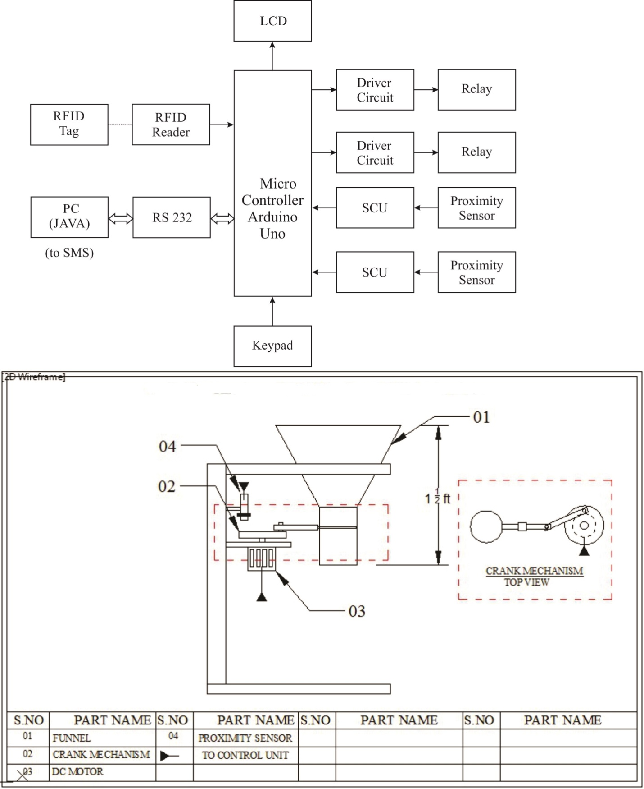

Fig 3.2 Block diagram of proposed system

##### CHAPTER 4

##### SYSTEM REQUIRMENTS

##### 4.1 SOFTWARE REQUIRMENTS

##### Windows Operating System (Windows 7, 8 or 10)

##### Arduino IDE (ARDUINO 1.6.12)

##### JAVA (NetBeans IDE 8.1)

##### HARDWARE REQUIRMENTS

##### Relay and Driver Circuits

##### LCD Display

##### Personal Computer

##### Arduino Mega2560

##### RS232

##### SCU

##### Keypad

##### Model part

##### RFID reader

##### 4.3 SOFTWARE DESCRIPTION

**4.3.1 ARDUINO IDE**

The Arduino Integrated Development Environment - or Arduino Software (IDE) - contains a text editor for writing code, a message area, a text console, a toolbar with buttons for common functions and a series of menus. It connects to the Arduino and Genuino hardware to upload programs and communicate with them.

Programs written using Arduino Software (IDE) are called sketches. These sketches are written in the text editor and are saved with the file extension .ino. The editor has features for cutting/pasting and for searching/replacing text. The message area gives feedback while saving and exporting and also displays errors. The console displays text output by the Arduino Software (IDE), including complete error messages and other information. The bottom right hand corner of the window displays the configured board and serial port. The toolbar buttons allow you to verify and upload programs, create, open, and save sketches, and open the serial monitor.

**4.3.2 JAVA**

Java is a general-purpose, concurrent, class-based, object-oriented computer programming language that is specifically designed to have as few implementation dependencies as possible. It is intended to let application developers "write once, run anywhere" (WORA), meaning that code that runs on one platform does not need to be recompiled to run on another. Java applications are typically compiled to byte code (class file) that can run on any Java virtual machine (JVM) regardless of computer architecture.

**4.4 HARDWARE DESCRIPTION**

**4.4.1 Driver Circuit**

In electronics, a **driver** is an electrical circuit or other electronic component used to control another circuit or other component, such as a high-power transistor. The term is used, for example, for a specialized computer chip that controls the high-power transistors in AC-to-DC voltage converters. An amplifier can also be considered the driver for loudspeakers, or a constant voltage circuit that keeps an attached component operating within a broad range of input voltages.

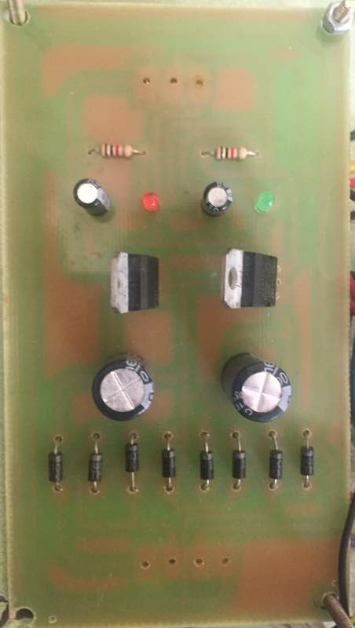

##### Fig 4.1(a) Driver Circuit

**Relay Circuit**

 A relay is an electrically operated switch. Current flowing through the coil of the relay creates a magnetic field which attracts a lever and changes the switch contacts. The coil current can be on or off so relays have two switch positions and the relays are doublethrow (changeover) switches. Relays allow one circuit to switch a second circuit which can be completely separate from the first. For example a low voltage battery circuit can use a relay to switch a 230V AC mains circuit. There is no electrical connection inside the relay between the two circuits; the link is magnetic and mechanical.

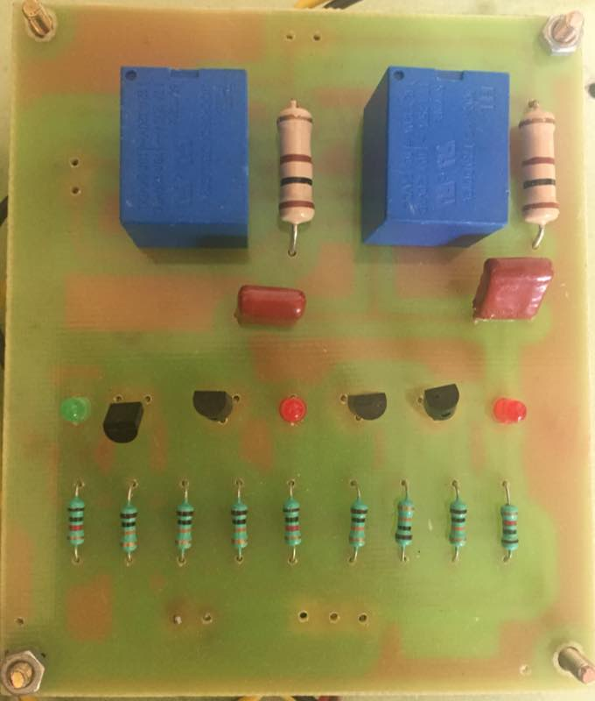

##### Fig 4.1(b) Relay Circuit

**4.4.2 LCD DISPLAY**

Liquid crystal displays (LCDs) have materials which combine the properties of both liquids and crystals. Rather than having a melting point, which have a temperature range within which the molecules are almost as mobile as which would be in a liquid, but are grouped together in an ordered form similar to a crystal.

An LCD consists of two glass panels, with the liquid crystal material sand witched in between them. The inner surface of the glass plates are coated with transparent electrodes which define the character, symbols or patterns to be displayed polymeric layers are present in between the electrodes and the liquid crystal, which makes the liquid crystal molecules to maintain a defined orientation angle.

One each polarizer's are pasted outside the two glass panels. These polarizer's would rotate the light rays passing through them to a definite angle, in a particular direction.

When the LCD is in the off state, light rays are rotated by the two polarizer's and the liquid crystal, such that the light rays come out of the LCD without any orientation, and hence the LCD appears transparent.When sufficient voltage is applied to the electrodes, the liquid crystal molecules would be aligned in a specific direction. The light rays passing through the LCD would be rotated by the polarizer's, which would result in activating / highlighting the desired characters.

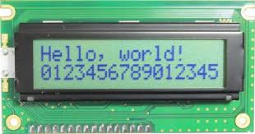

Fig 4.2LCD Display

**4.4.3 PC**

A **personal computer** (**PC**) is any general-purpose [computer](http://en.wikipedia.org/wiki/Computer) whose size, capabilities, and original sales price make it useful for individuals, and which is intended to be operated directly by an end user with no intervening computer operator. This is in contrast to the batch processing or [time-sharing](http://en.wikipedia.org/wiki/Time-sharing_system) models which allowed large expensive [mainframe](http://en.wikipedia.org/wiki/Mainframe_computer) systems to be used by many people, usually at the same time, or large data processing systems which required a full-time staff to operate efficiently.

A personal computer may be a [desktop computer](http://en.wikipedia.org/wiki/Desktop_computer), a [laptop](http://en.wikipedia.org/wiki/Laptop), a [tablet PC](http://en.wikipedia.org/wiki/Tablet_PC), or a [handheld PC](http://en.wikipedia.org/wiki/Handheld_PC) (also called a *palmtop*). The most common [microprocessors](http://en.wikipedia.org/wiki/Microprocessor) in personal computers are [x86](http://en.wikipedia.org/wiki/X86)-compatible CPUs. Software applications for personal computers include [word processing](http://en.wikipedia.org/wiki/Word_processing), [spreadsheets](http://en.wikipedia.org/wiki/Spreadsheets), [databases](http://en.wikipedia.org/wiki/Databases), [Web browsers](http://en.wikipedia.org/wiki/Web_browser) and [e-mail](http://en.wikipedia.org/wiki/E-mail) clients, [games](http://en.wikipedia.org/wiki/Personal_computer_game), and myriad personal productivity and special-purpose software applications. Modern personal computers often have connections to the [Internet](http://en.wikipedia.org/wiki/Internet), allowing access to the [World Wide Web](http://en.wikipedia.org/wiki/World_Wide_Web) and a wide range of other resources.

A PC may be used at home or in an office. Personal computers may be connected to a [local area network](http://en.wikipedia.org/wiki/Local_area_network) (LAN), either by a cable or a wireless connection.

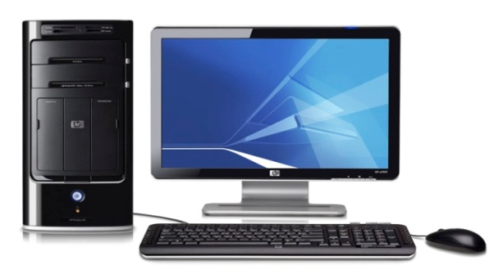

Fig 4.3 PC

**4.4.4 ARDUINO MEGA 2560**

The Arduino Mega 2560 is a microcontroller board based on the ATmega2560 (datasheet). It has 54 digital input/output pins (of which 14 can be used as PWM outputs), 16 analog inputs, 4 UARTs (hardware serial ports), a 16 MHz crystal oscillator, a USB connection, a power jack, an ICSP header, and a reset button. It contains everything needed to support the microcontroller; simply connect it to a computer with a USB cable or power it with a AC-to-DC adapter or battery to get started. The Mega is compatible with most shields designed for the Arduino Duemilanove or Diecimila.

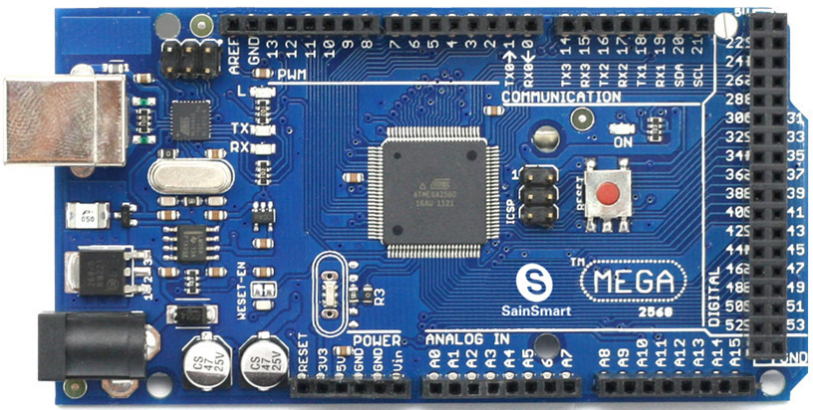

Figure 4.4 Arduino Mega 2560.

The Arduino Mega2560 can be powered via the USB connection or with an external power supply. The power source is selected automatically. External (non-USB) power can come either from an AC-to-DC adapter (wall-wart) or battery. The adapter can be connected by plugging a 2.1mm centre-positive plug into the board's power jack. Leads from a battery can be inserted in the Gnd and Vin pin headers of the POWER connector. The board can operate on an external supply of 6 to 20 volts. If supplied with less than 7V, however, the 5V pin may supply less than five volts and the board may be unstable. If using more than 12V, the voltage regulator may overheat and damage the board. The recommended range is 7 to 12 volts. The Mega2560 differs from all preceding boards in that it does not use the FTDI USB-to-serial driver chip. Instead, it features the Atmega8U2 programmed as a USB-to-serial converter.

**VIN-** The input voltage to the Arduino board when it's using an external power source (as opposed to 5 volts from the USB connection or other regulated power source). You can supply voltage through this pin, or, if supplying voltage via the power jack, access it through this pin.

**5V.** The regulated power supply used to power the microcontroller and other components on the board. This can come either from VIN via an on-board regulator, or be supplied by USB or another regulated 5V supply.

**3V3.** A 3.3 volt supply generated by the on-board regulator. Maximum current draw is 50 mA.

**GND.** Ground pins.

**4.4.5 RS 232**

In telecommunications, **RS-232** is a standard for serial binary data interconnection between a *DTE* (Data terminal equipment) and a *DCE* (Data Circuit-terminating Equipment). It is commonly used in computer serial ports.

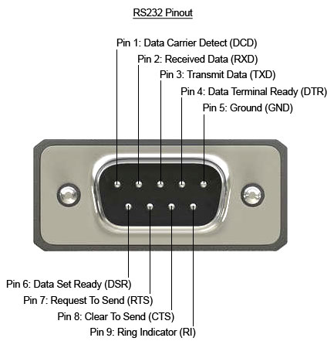

Figure 4.5 RS 232.

**Scope of the Standard:**

The Electronic Industries Alliance (EIA) standard RS-232-C [3] as of 1969 defines:

* Electrical signal characteristics such as voltage levels, signaling rate, timing and slew-rate of signals, voltage withstand level, short-circuit behavior, maximum stray capacitance and cable length
* Interface mechanical characteristics, pluggable connectors and pin identification
* Functions of each circuit in the interface connector
* Standard subsets of interface circuits for selected telecom applications

The standard does not define such elements as character encoding (for example, ASCII, Bardot or EBCDIC), or the framing of characters in the data stream (bits per character, start/stop bits, parity). The standard does not define protocols for error detection or algorithms for data compression.

The standard does not define bit rates for transmission, although the standard says it is intended for bit rates lower than 20,000 bits per second. Many modern devices can exceed this speed (38,400 and 57,600 bit/s being common, and 115,200 and 230,400 bit/s making occasional appearances) while still using RS-232 compatible signal levels.

Details of character format and transmission bit rate are controlled by the serial port hardware, often a single integrated circuit called a UART that converts data from parallel to serial form. A typical serial port includes specialized driver and receiver integrated circuits to convert between internal logic levels and RS-232 compatible signal levels.

**4.4.6 SIGNAL CONDITIONING UNIT (SCU):**

The signal conditioning unit accepts input signals from the analog sensors and gives a conditioned output of 0-5V DC corresponding to the entire range of each parameter.  This unit also accepts the digital sensor inputs and gives outputs in 10 bit binary with a positive logic level of +5V.  The calibration voltages* (0, 2.5 and 5V) and the health bits are also generated in this unit.

Microcontrollers are widely used for control in power electronics. It provides real time control by processing analog signals obtained from the system. A suitable isolation interface needs to be designed for interaction between the control circuit and high voltage hardware. A signal conditioning unit which provides necessary interface between a high power grid inverter and a low voltage controller unit.

**4.4.7 KEYPAD**

**GENERAL EXPLANATION:**

A group of keys in a single printed circuit board is call key pad. These key pads are classified into two types.

1. Key pad
2. Matrix keypad

**KEYPAD**

In a key pad it has one or more than one keys placed in a PCB. And all the keys are commonly grounded. This is the main difference when compared to a matrix keypad. This key pad has a maximum of 8 keys. If we need more than 8 keys, we can operate it in a matrix keypad.

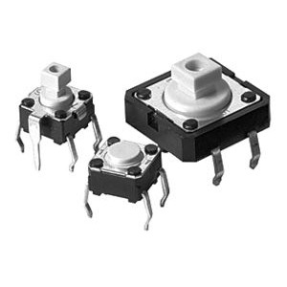**KEY:**

**Fig 4.7 Key**

**4.4.8 MODELPART**

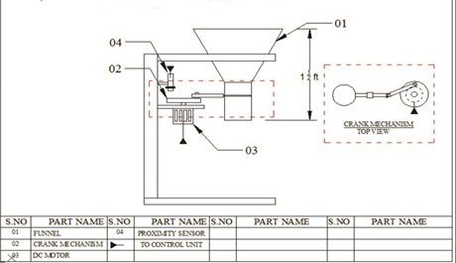

Fig 4.8 Model Part

**FUNNEL:**

This is used to channel or guide the flow of the subsidized products into a small opening i.e. it helps to dispense the products with the help of an opening which is found below, this opening is closed initially.

Depending upon the amount (quantity) of product to be dispensed say for ex: 1kg of rice, the opening would remain open for a specific amount of time (in seconds) with the help of a crank mechanism.

**DC MOTOR:**

A [DC motor](https://www.electrical4u.com/dc-motor-or-direct-current-motor/) in simple words is a device that converts electrical energy (direct current system) into mechanical energy. In this scenario it aids in the regulation of the crank mechanism.

**PROXIMITY SENSOR:**

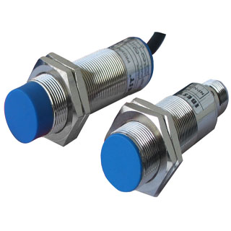

Fig 4.8(b) Proximity Sensor

A proximity sensor, in particular a proximity switch is described. A component that pertains to a system variable and is independent from the material of a trigger or target is elected and transformed into a non-periodic signal that depends upon the distance of the trigger.

The trigger of a proximity sensor can thus be exchanged randomly without requiring subsequent adjustments. The impedance of an oscillation circuit which pertains to the proximity sensor, the impedance of an oscillation circuit coil, the amplitude of the oscillation circuit signal or a voltage divider ratio between the oscillation circuit and the additional resistance can be used s system variables for instance.

A proximity sensor for determining an approaching direction of an object is provided. Relative detection sensitivity is established in a first detection unit and a second detection unit such that a detection level of the first detection unit is greater than a detection level of the second detection unit when the object approaches from a first electrode in a direction of arranging the first electrode and a second electrode, and that the detection level of the second detection unit is greater than the first detection unit when the object approaches from a direction perpendicular to the direction of arranging the first electrode and the second electrode. A proximity position determining section is adapted to determine the approaching direction of the object based on the detection level of the first detection unit and the detection level of the second detection unit.

**CRANK MECHANISM:**

A **crank** is an arm attached at a right angle to a rotating shaft by which [reciprocating motion](https://en.wikipedia.org/wiki/Reciprocating_motion) is imparted to or received from the shaft. It is used to convert [circular motion](https://en.wikipedia.org/wiki/Circular_motion) into reciprocating motion, or vice versa. The arm may be a bent portion of the shaft, or a separate arm or disk attached to it. Attached to the end of the crank by a pivot is a rod, usually called a [connecting rod](https://en.wikipedia.org/wiki/Connecting_rod) (conrod). The end of the rod attached to the crank moves in a circular motion, while the other end is usually constrained to move in a [linear](https://en.wikipedia.org/wiki/Linear_motion) sliding motion.

The term often refers to a human-powered crank which is used to manually turn an axle, as in a [bicycle](https://en.wikipedia.org/wiki/Bicycle) [crank set](https://en.wikipedia.org/wiki/Crankset) or a [brace and bit](https://en.wikipedia.org/wiki/Brace_and_bit) drill. In this case a person's arm or leg serves as the connecting rod, applying reciprocating force to the crank. There is usually a bar perpendicular to the other end of the arm, often with a freely rotatable handle or [pedal](https://en.wiktionary.org/wiki/Pedal) attached.

##### 4.9 RFID READER

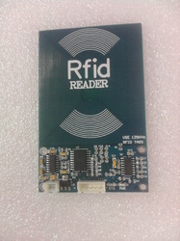

Fig 4.9 RFID Reader

The RFID reader reads EM4100 family transponder tags that are brought in proximity to the reader and output the unique tag identification number through RS232 serial port @9600 bps. The reader output 12 byte including one start, stop byte and 10 unique data byte. The start byte and stop byte are used to easily identify that a correct string has been received from the reader (which corresponds to a line feed and carriage return characters, respectively). The middle ten bytes are the actual tag's unique ID. Vertical and horizontal parity checking has been done in card reading algorithm to ensure data integrity. One status LED is provided to detection.  
 RFID (radio frequency identification) systems use data strings stored inside RFID tags or transponders) to uniquely identify people or objects are scanned by an RFID reader. These types of systems are found in many applications such as passport protection, animal identification, inventory control systems, and secure access control systems, robotics, navigation, inventory tracking, payment systems, and car immobilization. Because passive tags require a strong RF field to operate, the effective range is limited to an area in close proximity to the RFID reader.

**Product Features**

* Low-cost method for reading passive RFID EM4100 family transponder tags
* Reading Distance 10-15CM of the reader (Depend card shape)
* 125kHz read frequency
* 9600 baud RS232 serial interface
* Standard 2.54mm Pitch Bergstrip connector
* Bread Board compatible
* Low power Requirement 7-9V @ 100mA
* Small Size
* Built in Antenna
* No components at PCB bottom side ( easy to stick to any surface like wood,glass etc)
* Status LED for card detection
* On-Board Power LED

**Key Specifications:**

* Power requirements     :  7-9VDC
* Current Requirement    :  <110mA
* Communication            :  RS232 Serial at 9600 baud (8N1)
* Dimensions                  :  63mm x 98mm x 5 mm
* Operating temp range   : -40 to +185 °F (-40 to +85 °C)

This is a basic VLF RFID tag used for presence sensing, Aceess Control etc. Works in the 125kHz RF range. These tags come with a unique 32-bit ID and are not re-programmable. Card is blank, smooth, and mildly flexible.

**RFID Clamshell Card (125kHz) Features:**

* EM4001 ISO based RFID IC
* 125kHz Carrier
* 2kbps ASK
* Manchester encoding
* 32-bit unique ID
* 64-bit data stream [Header+ID+Data+Parity]

**Dimensions:** 54 x 85.5 x 1.8mm

##### 

##### CHAPTER 5

**METHODOLOGY**

**5.1 SYSTEM ARCHITECTURE**

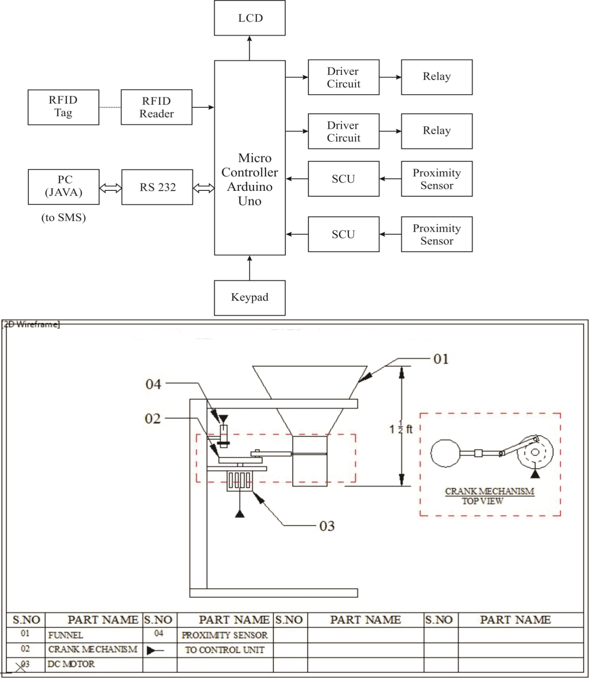

**5.2 WORKING PROCEDURE (Hardware):**

Initially the RFID tag of the corresponding valid card holder would be shown near the RFID reader which is embedded in the Arduino mega controller and this reader would sense/read the card and display the details (information) encoded in the card on the LCD display. After that the LCD display which is also embedded in the Arduino mega controller would prompt the user to choose the subsidized product which he/she wants with the required quantity. Till this point of time, the flow of control was carried out by the Arduino mega controller ,after which the flow of control gets transferred to the model part where the funnel opening would remain opened for a specific amount of time, based on the quantity selected by the user. This is regulated with the help of a DC motor and a proximity sensor by a crank mechanism. The subsidized products are thus dispensed along the funnel, after the required quantity is gathered an SMS would be sent to the corresponding valid card holder regarding the purchases made by him/her also indicating the availability of products in quantitative terms.

**5.3 WORKING PROCEDURE (Software):**

The software’s used in the project are Arduino IDE and Java. Java is used for interfacing the Arduino Mega controller with the PC. The java code helps to send the SMS to the valid card holder and also display the details of the corresponding valid card holder in a basic GUI. The interfacing is done using the respective port numbers.

The Arduino IDE is used to write control code for the Arduino Mega controller. The Arduino Mega controller has been coded in such a way to send values to the LED display.The coding implementation of Arduino IDE given below.

**5.3.1 Code (ARDUINO IDE):**

#include <LiquidCrystal.h>

#include <EEPROM.h>

#include <string.h>

char card1[13]="08009565C3";

char card2[13]="080095743D";

char card3[13]="0800954E1E";

LiquidCrystal lcd(A1,A2,10,9,8,A0);

int user[13],p,set_key=1,num,enter_key;

unsigned int E;

const int relay1=13;

const int relay2=7;

const int relay3=12;

const int relay4=11;

const int Set=2;

const int mov=3;

const int inc=4;

const int dec=5;

const int ent=6;

char rec[13],index;

unsigned char set_value;

void mydecimal(unsigned int val,char pos,char j)

{

unsigned int Lcd_h,Lcd_hr,Lcd_t,Lcd_o;

Lcd_h=val/100;

Lcd_hr=val%100;

Lcd_t=Lcd_hr/10;

Lcd_o=Lcd_hr%10;

lcd.setCursor(0+pos,j);

lcd.write(Lcd_h+0x30);

lcd.setCursor(1+pos,j);

lcd.write(Lcd_t+0x30);

lcd.setCursor(2+pos,j);

lcd.write(Lcd_o+0x30);

}

void Lcd8_Decimal3(unsigned char val)

{

unsigned int Lcd_h,Lcd_hr,Lcd_t,Lcd_o;

Lcd_h=val/100;

Lcd_hr=val%100;

Lcd_t=Lcd_hr/10;

Lcd_o=Lcd_hr%10;

Serial.print(Lcd_h);

Serial.print(Lcd_t);

Serial.print(Lcd_o);

}

void scan()

{

if(set_key==1)

{

if(digitalRead(inc)==0)

{

delay(20);

while(digitalRead(inc)==0);

num=(user[p])+1;

if(num<=0) num=0;

if(num>=9) num=9;

user[p]=num;

lcd.setCursor(12+p,1);

lcd.print(num);

lcd.setCursor(12+p,1);

}

if(digitalRead(dec)==0)

{

delay(20);

while(digitalRead(dec)==0);

num=(user[p])-1;

if(num<=0) num=0;

if(num>=9) num=9;

user[p]=num;

lcd.setCursor(12+p,1);

lcd.print(num);

lcd.setCursor(12+p,1);

}

if(digitalRead(mov)==0)

{

delay(200);

while(digitalRead(mov)==0);

p++;

num=0;

if(p>=3) p=0;

lcd.setCursor(12+p,1);

}

}

}

void check()

{

if(digitalRead(Set)==0)

{

delay(20);

while(digitalRead(Set)==0);

E++;

lcd.cursor();

lcd.setCursor(0, 0);

lcd.print("ENTER THE NUMBER");

lcd.setCursor(0, 1);

lcd.print(" ");

delay(20);

set_key=1;

p=0;

enter_key=0;

}

if(digitalRead(ent)==0)

{

delay(20);

while(digitalRead(ent)==0);

set_value=(user[0]*100)+(user[1]*10)+(user[2]*1);

enter_key=1;

lcd.clear();

}

}

char card=0,good=0;

unsigned char c1_rice=50,c1_sugar=50;

unsigned char c2_rice=50,c2_sugar=50;

unsigned char c3_rice=50,c3_sugar=50;

void timer()

{

unsigned char count=0,count1=0,one=0,two=0;

count1=set_value*3;

while(count<count1)

{

mydecimal(count1-count,13,1);

if(good==1)

{

if(one==0)

{

one=1;

digitalWrite(relay1, LOW);

digitalWrite(relay2, HIGH);

delay(1000);

digitalWrite(relay1, HIGH);

digitalWrite(relay2, HIGH);

}

}

else if(good==2)

{

if(two==0)

{

two=1;

digitalWrite(relay3, LOW);

digitalWrite(relay4, HIGH);

delay(1000);

digitalWrite(relay3, HIGH);

digitalWrite(relay4, HIGH);

}

}

count++;

delay(600);

}

digitalWrite(relay1, HIGH);

digitalWrite(relay2, LOW);

digitalWrite(relay3, HIGH);

digitalWrite(relay4, LOW);

delay(1000);

digitalWrite(relay1, HIGH);

digitalWrite(relay2, HIGH);

digitalWrite(relay3, HIGH);

digitalWrite(relay4, HIGH);

}

void call()

{

char looping=0;

while(looping==0)

{

if(enter_key==1)

{

lcd.setCursor(0, 0);

lcd.print("NEEDED: Kg");

mydecimal(set_value,7,0);

if(good==1)

{

if(card==1)

{

if(set_value>c1_rice)

{

lcd.clear();

lcd.setCursor(0, 0);

lcd.print(" INSUFFICIENT ");

delay(1000);

looping=1;

}

else

{

timer();

looping=1;

} }

else if(card==2)

{

if(set_value>c2_rice)

{

lcd.clear();

lcd.setCursor(0, 0);

lcd.print(" INSUFFICIENT ");

delay(1000);

looping=1;

}

else

{

timer();

looping=1;

}

}

else if(card==3)

{

if(set_value>c3_rice)

{

lcd.clear();

lcd.setCursor(0, 0);

lcd.print(" INSUFFICIENT ");

delay(1000);

looping=1;

}

else

{

timer();

looping=1;

}

}

}

else if(good==2)

{

if(card==1)

{

if(set_value>c1_sugar)

{

lcd.clear();

lcd.setCursor(0, 0);

lcd.print(" INSUFFICIENT ");

delay(1000);

looping=1;

}

else

{

timer();

looping=1;

}

}

else if(card==2)

{

if(set_value>c2_sugar)

{

lcd.clear();

lcd.setCursor(0, 0);

lcd.print(" INSUFFICIENT ");

delay(1000);

looping=1;

}

else

{

timer();

looping=1;

}

}

else if(card==3)

{

if(set_value>c3_sugar)

{

lcd.clear();

lcd.setCursor(0, 0);

lcd.print(" INSUFFICIENT ");

delay(1000);

looping=1;

}

else

{

timer();

looping=1;

}

}

}

}

else

{

scan();

check();

}

}

enter_key=0;

p=0;

}

void rfid()

{

if(index>=10)

{

int j;

for(j=0;j<10;j++)

{

lcd.setCursor(0+j, 1);

lcd.write(rec[j]);

}

if( (strncmp(rec,card1,10)) == 0)

{

card=1;

lcd.setCursor(11, 1);

lcd.print("KAMAL ");

delay(1000);

lcd.clear();

lcd.setCursor(0, 0);

lcd.print("1.RICE 2.SUGAR");

while(digitalRead(inc) && digitalRead(dec)) ;

if(digitalRead(inc)==0) good=1;

else if(digitalRead(dec)==0) good=2;

lcd.clear();

if(good==1)

{

lcd.setCursor(0, 0);

lcd.print("AVAIL RICE :");

mydecimal(c1_rice,12,0);

lcd.setCursor(0, 1);

lcd.print("SELECT Kg :");

delay(1000);

call();

if(set_value<=c1_rice) c1_rice-=set_value;

lcd.clear();

lcd.setCursor(0, 0);

lcd.print(" SHOW YOUR CARD ");

}

else if(good==2)

{

lcd.setCursor(0, 0);

lcd.print("AVAIL SUGAR:");

mydecimal(c1_sugar,12,0);

lcd.setCursor(0, 1);

lcd.print("SELECT Kg :");

delay(1000);

call();

if(set_value<=c1_sugar) c1_sugar-=set_value;

lcd.clear();

lcd.setCursor(0, 0);

lcd.print(" SHOW YOUR CARD ");

}

Serial.print("*1");

Lcd8_Decimal3(set_value);

Lcd8_Decimal3(c1_rice);

Lcd8_Decimal3(c1_sugar);

Serial.write('\r');

}

else if( (strncmp(rec,card2,10)) == 0)

{

card=2;

lcd.setCursor(11, 1);

lcd.print(" GURU ");

delay(1000);

lcd.clear();

lcd.setCursor(0, 0);

lcd.print("1.RICE 2.SUGAR");

while(digitalRead(inc) && digitalRead(dec)) ;

if(digitalRead(inc)==0) good=1;

else if(digitalRead(dec)==0) good=2;

lcd.clear();

if(good==1)

{

lcd.setCursor(0, 0);

lcd.print("AVAIL RICE :");

mydecimal(c2_rice,12,0);

lcd.setCursor(0, 1);

lcd.print("SELECT Kg :");

delay(1000);

call();

if(set_value<=c2_rice) c2_rice-=set_value;

lcd.clear();

lcd.setCursor(0, 0);

lcd.print(" SHOW YOUR CARD ");

}

else if(good==2)

{

lcd.setCursor(0, 0);

lcd.print("AVAIL SUGAR:");

mydecimal(c2_sugar,12,0);

lcd.setCursor(0, 1);

lcd.print("SELECT Kg :");

delay(1000);

call();

if(set_value<=c2_sugar) c2_sugar-=set_value;

lcd.clear();

lcd.setCursor(0, 0);

lcd.print(" SHOW YOUR CARD ");

}

Serial.print("*2");

Lcd8_Decimal3(set_value);

Lcd8_Decimal3(c2_rice);

Lcd8_Decimal3(c2_sugar);

Serial.write('\r');

}

else if( (strncmp(rec,card3,10)) == 0)

{

card=3;

lcd.setCursor(11, 1);

lcd.print(" RAJA ");

delay(1000);

lcd.clear();

lcd.setCursor(0, 0);

lcd.print("1.RICE 2.SUGAR");

while(digitalRead(inc) && digitalRead(dec)) ;

if(digitalRead(inc)==0) good=1;

else if(digitalRead(dec)==0) good=2;

lcd.clear();

if(good==1)

{

lcd.setCursor(0, 0);

lcd.print("AVAIL RICE :");

mydecimal(c3_rice,12,0);

lcd.setCursor(0, 1);

lcd.print("SELECT Kg :");

delay(1000);

call();

if(set_value<=c3_rice) c3_rice-=set_value;

lcd.clear();

lcd.setCursor(0, 0);

lcd.print(" SHOW YOUR CARD ");

}

else if(good==2)

{

lcd.setCursor(0, 0);

lcd.print("AVAIL SUGAR:");

mydecimal(c3_sugar,12,0);

lcd.setCursor(0, 1);

lcd.print("SELECT Kg :");

delay(1000);

call();

if(set_value<=c3_sugar) c3_sugar-=set_value;

lcd.clear();

lcd.setCursor(0, 0);

lcd.print(" SHOW YOUR CARD ");

}

Serial.print("*3");

Lcd8_Decimal3(set_value);

Lcd8_Decimal3(c3_rice);

Lcd8_Decimal3(c3_sugar);

Serial.write('\r');

}

index=0;

}

}

void setup()

{

pinMode(relay1, OUTPUT);

pinMode(relay2, OUTPUT);

pinMode(relay3, OUTPUT);

pinMode(relay4, OUTPUT);

digitalWrite(relay1, HIGH);

digitalWrite(relay2, HIGH);

digitalWrite(relay3, HIGH);

digitalWrite(relay4, HIGH);

pinMode(Set,INPUT_PULLUP);

pinMode(mov,INPUT_PULLUP);

pinMode(inc,INPUT_PULLUP);

pinMode(dec,INPUT_PULLUP);

pinMode(ent,INPUT_PULLUP);

lcd.begin(16, 2);

lcd.setCursor(0, 0);

lcd.print(" SHOW YOUR CARD ");

lcd.setCursor(0, 1);

lcd.print(" ");

Serial.begin(9600); // start serial for output

Serial.println("WORKING FINE");

}

void loop()

{

rfid();

}

void serialEvent()

{

if(Serial.available())

{

rec[index++]=(char)Serial.read();}}

**5.4 SEQUENCE DIAGRAM:**

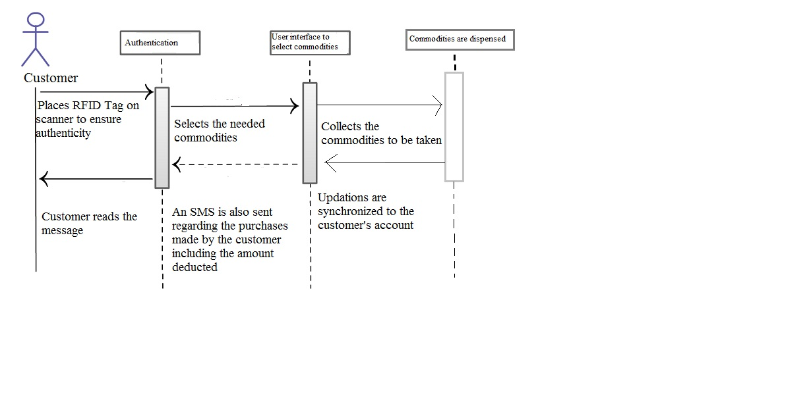

Figure 5.4 Sequence Diagram for Ration shop Automation System

**5.5 USE CASE DIAGRAM:**

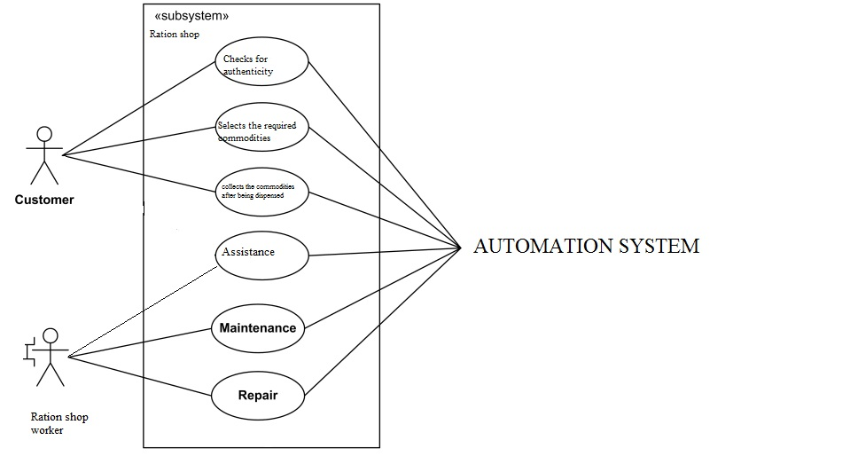

Fig 5.5 Use case diagram for Ration shop Automation System

**5.6 ACTIVITY DIAGRAM:**

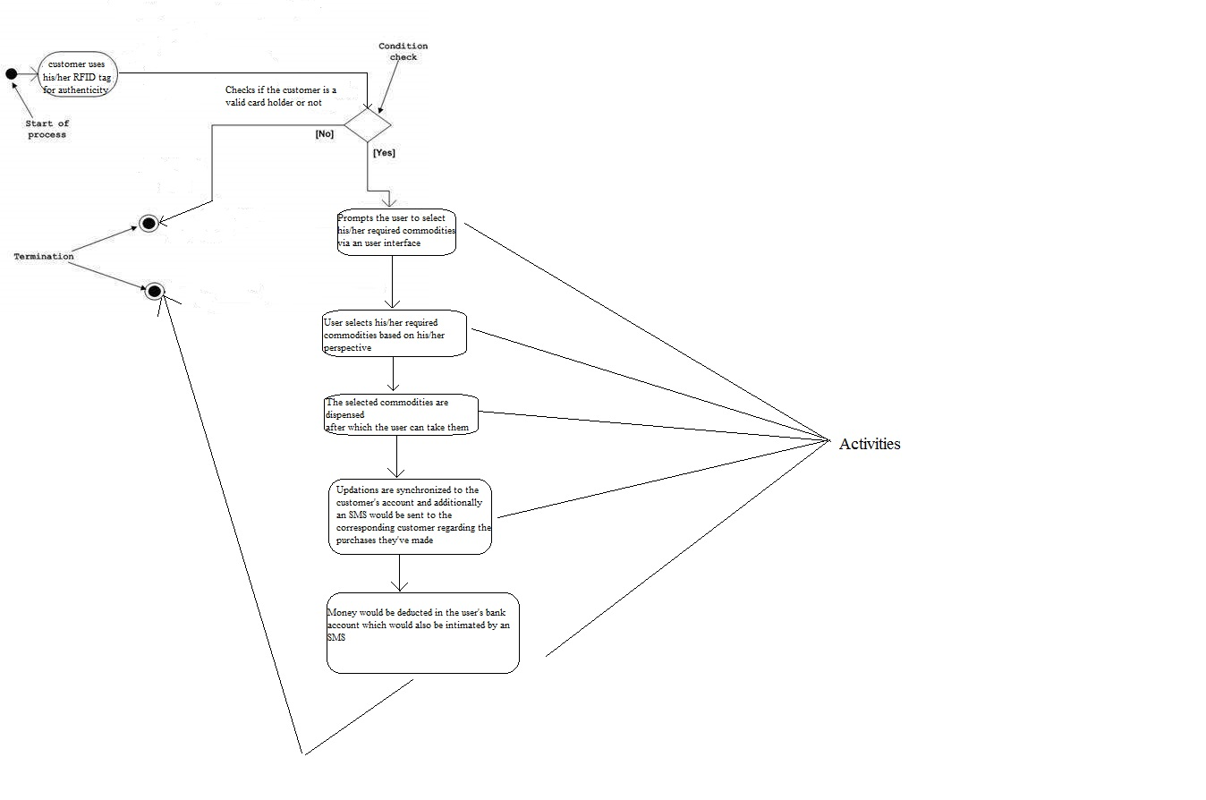Fig 5.6 Activity Diagram for Ration shop Automation System

**CONCLUSION**

The progress in science & technology is a non-stop process. New things and new technology are being invented. As the technology grows day by day, the future can be imagined. The user can get alerts anywhere through the GSM technology thus making the system location independent. A flexible way to control and explore the services of the mobile, AT commands is used in the system. The communication of home is only through the SMS which has been tested with the mobile networks and is working on any mobile network.

The proposed system based on ARDUINO is found to be more compact, user friendly and less complex, which can readily be used in order to perform several tedious and repetitive tasks. Though it is designed keeping in mind about the need for industry, it can extended for other purposes such as commercial & research applications. Due to the probability of high technology uses fully software controlled with less hardware circuit. The feature makes the system is the base for future systems.

The principle of the development of science is that “nothing is impossible”. So let us look forward to a bright & sophisticated world.

**REFERENCES:**

[1]. A.N.Madur,Sham Nayse -Automation in Rationing System using Arm. International Research Journal of Engineering and Technology Volume 02 Issue 03 June-2015.

[2]. Rajesh C. Pingle, P. B. Borole-Automatic Rationing for Public Distribution System (PDS) using RFID and GSM Module to Prevent Irregularities. International Journal of Technical Research and Applications Volume 3, Issue 6 December, 2015.

[3].S.Valarmathy,R.Ramani-Automatic Ration Material Distributions Based on GSM and RFID Technology.International Journal of Technical Research and Applications Volume1,Issue 8, November 2013.

[4].S.Sukhumar, K.Gopinathan, S.Kalpanadevi, P.Naveenkumar, N.Suthanthira Vanitha *-*International Journal Of Innovative Research In Electrical, Electronics, Instrumentation and Control Engineering Vol. 1, Issue 8, November 2013

[5]. <http://www.arduino.org/?gclid=CNSdsZ71o9MCFdASaAodLBQOdA>

[6].<http://discuss.littlebits.cc/t/introduction-to-arduino-programming-1-the-basics/22237>

[7].<http://www.tutorialspoint.com/arduino/>